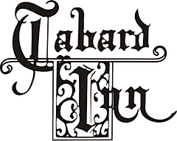

For 104 years, The Tabard Inn has nurtured a rich, storied culinary tradition. This Fall Restaurant Week, we invite you to experience a specially curated prix-fixe menu that celebrates our unique Mid-Atlantic and Appalachian roots. Infused with our signature creativity and a touch of whimsy, each dish is a tribute to our heritage.

Please note: We are happy to accommodate most dietary restrictions, call ahead for details.
Our classic à la carte menu will also be available.

RAMW Restaurant Week $65

First Course

Yellowfin Tuna Crudo
green tomato gazpacho, pickled cantaloupe, benne seed praline

Second Course

Shrimp & Grits
creamy stone-ground grits, lobster broth

Main Course

Roasted Rabbit or Grilled Skirt Steak
baby carrots, herb vinaigrette

Dessert

Chocolate & Bourbon
dark chocolate crémeux, bourbon caramel, cocoa crumble



