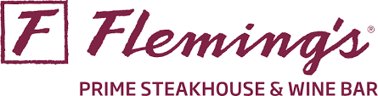

Restaurant Week Menu
$55/guest

Starter (choice of)

Fleming's Salad
Caesar Salad
Lobster Bisque
Mushroom Brie Soup

Entree (choice of)

Petite Filet Mignon 8oz
Suggested: FRANCISCAN ESTATE, Cabernet Sauvignon, California $12/glass

Double Breast of Chicken - all natural, white wine, mushrooms, leek & thyme sauce
Suggested: CUVAISON, Chardonnay $18/glass

Barbecue Salmon Fillet - mushrooms, barbecue glaze, cilantro oil
Suggested: A to Z WINEWORKS, Pinot Noir, Oregon $16/glass

Jumbo Lump Crab Cakes - roasted red pepper & lime butter sauce
Suggested: LOOSEN BROS., Dr. L, Riesling, Mosel Germany $11/glass

36-Hour Braised Short Rib – truffle garlic mashed potatoes, port wine demi-glace
Suggested: DOMAINE FRANCOIS VILLARD, Syreines, Syrah, Rhone Valley, France $18/glass

Upgrade Options
Australian Carrara Wagyu Filet 8oz +$27
Suggested: DAOU VINEYARDS, Cabernet Sauvignon, Paso Robles $18/glass
Prime Bone-In Ribeye 20oz +$22
Suggested: QUILT, Cabernet Sauvignon, Napa Valley $22/glass

Add Garlic Butter Mushroom Medley $18
Add Diablo Shrimp in Barbecue Butter $20
Add 12oz North Atlantic Lobster Tail $67

Dessert (choice of)

New York Style Cheesecake with Strawberry Sauce
Chocolate Gooey Butter Cake with Caramel and Honeycomb Brittle

